WebRatio RTF Filler Unit Sample

What is WebRatio
$$WebRatioDescription$$

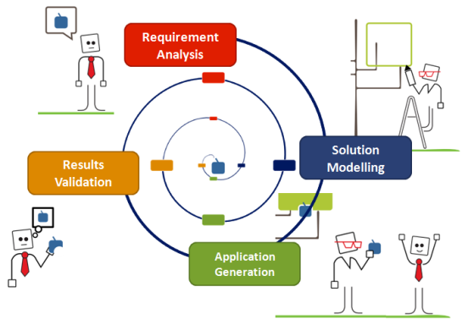
The Evolutionary Prototyping Development Cycle
The development process of a WebRatio process is highly iterative. We call it “evolutionary prototyping development cycle”. At any stage of your project, even after a few minutes, you can automatically generate the 100% of your application and test it immediately. In such way, you will have an immediate feedback of what you have done and you can react accordingly.

Features
$$features$$

Pricing
Product | Price
$$product$$ | $$price$$
Total | $$total$$

The WebRatio approach to BPM: build custom BPM applications
Instead of offering a whole platform comprehensive of all the typical features of a BPMS, WebRatio clearly distinguishes between design-time features and run-time features. At design-time WebRatio offers you a powerful modelling and development environment, allowing you to define all the requirements of your BPM project by capturing them in abstract models and custom components. At run-time, starting from the models, WebRatio generates a standalone custom BPM application that can be easily deployed on any standard Java Application Server.
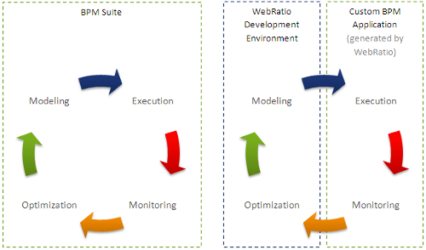
The development process of a BPM project with WebRatio is highly iterative. We call it “evolutionary prototyping development cycle”. At any stage of your project, even after a few minutes, you can generate the BPM application and test it immediately. In such way you will have an immediate feedback of what you have done and you can react accordingly. This kind of development process allows you to involve (if you want) your business users or your stakeholder in the evaluation of the work in progress.
$$slogan$$

